Name: _________________________________________ Date: ________________

FOLKLIFE BINGO

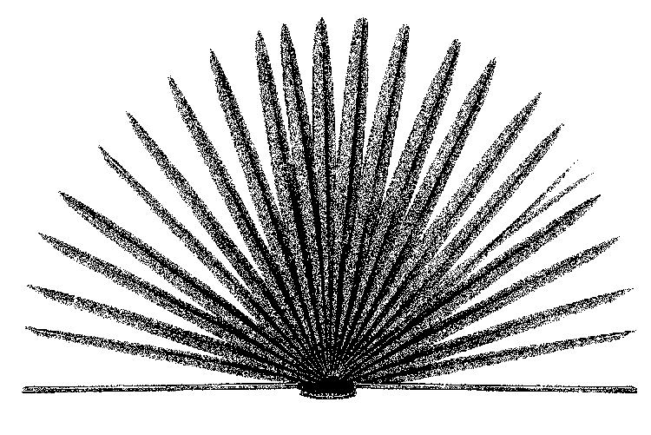

Louisiana Folklife Bingo Suggestions
Here are suggestions for Folklife Bingo. Note that some things could be in other regions. Consider the cultural groups unique to your area and add your own.

New Orleans  I give directions using the river, the lake, Uptown and Downtown.  I have been in a Mardi Gras parade.  I have been to at least three crawfish boils in the last two years.  Someone in my family lives in a camelback house.  I have eaten a Cajun-, Kosher-, or Filipino egg roll in the past year.  After midnight mass my family stays up for le Revillon.  I know which snowball flavor is the best.  Someone in my family has caught a Zulu coconut.  I have participated in a seder.  I have attended a piñata party.  I know 2 home cures for warts.  A language other than English is spoken in my home.  I can tell you which days the Big Chief and the Wild Man step out.  I have danced to music played in the streets.  I grew up eating real Creole cream cheese and pralines.  I know how to make pralines.  I have a fig tree in my yard.  I never refer to “trolleys” or “medians.”  I’ve attended a Hispanic, Greek, or Italian festival in the past year.  I’ve gotten the baby at a King Cake party.  My parents gave me coffee-milk.  My house is on stilts.  I celebrate “my saint’s day” or have a favorite saint.  Someone in my family is “buried in an oven.”  I carry a “lucky bean” from a St. Joseph’s Altar.  I ate rice for supper last night.  I caught a cabbage at the St. Patrick’s Day parade.  I played “high waters” as a child (jump rope game).  I have an altar in my house or yard.  I know how to play Mah-Jongg.  A family member taught me how to make gumbo.  I know someone who uses a hand-knotted rosary.  My house’s brick-, plaster-, or ironwork was done by family members.  I know someone who received silver dimes (or their first rosary) at First Communion.  I have been to the Vietnamese market in New Orleans East.  I have been to the French Market.  I like to ride the street car.  I march in a band.  I eat snowballs in the summer.  I have a handmade quilt in my house.  There are shrimp in my freezer that someone caught and gave to me.  I have followed or attended the St. Rosalie procession.  I made a stew after attending the St. Patrick’s Day parade.  Someone in my family parades in a social aid and pleasure club.  I know someone who uses the expression, "I'm going to make groceries."  I have gone to Louis Armstrong Park to hear music.  I have gone to a club and listened to jazz in the past year.  My house has brickwork, plasterwork, or ironwork done by someone in our family.  I preserved figs sometime in the last five years.  I know who Tootie Montana is.  The grocery store near me sells dressed poboys.  I know what a camelback is. | South Louisiana  I give directions using bayouside, up the bayou, and down the bayou.  I attended a St. Joseph altar this year.  I have made my own Mardi Gras costume.  I have ridden on a Mardi Gras parade float.  I have been to a crawfish boil.  My parents gave me coffee-milk.  I celebrate “my saint’s day” or have a favorite saint.  I have pinned a dollar on a bride or groom.  I eat red beans and rice on Mondays and fish on Fridays.  I’ve whitewashed or decorated a relative’s grave on All Saints’ Day.  I have participated in the “laying on of hands” at church.  I own a crawfish pot.  I grew up hearing stories about hurricanes.  I know 2 home cures for warts.  I know how to stuff a merliton, and how to pronounce it.  Someone in my family lives in a shotgun.  I have an altar in my house or yard.  A family member taught me how to make gumbo.  I have a quilt made by someone in my family.  There are shrimp in my freezer that someone caught and gave to me.  I have a hand carved duck decoy.  I know someone who grows oranges and sells them in front of their house.  I know someone who uses a hand-knotted rosary.  I have gone to a club and listened to zydeco in the past year.  I preserved figs sometime in the last five years.  I know who Dewey Balfa was.  I've participated in or have attended the St. Amico procession.  I know someone who owns a Job's Tears rosary.  Someone in my family lives in a shotgun.  I know someone who participates in Easter Egg "Knocking" or "Pocking."  I can tell three Boudreaux and Thibodeaux jokes (be prepared to tell them!).  I have eaten a spoon full of sugar to get rid of hiccups.  I know what a frottoir is.  I know somebody who plays the accordion.  I have a friend or relative that owns a Catahoula cur.  I only drink Community Coffee.  I know someone who has competed in a rodeo at least twice.  A language other than English is spoken in my home.  There is a Native American reservation less than 30 minutes from my home.  Someone in my family has a chair with a cowhide bottom.  I know the difference between gumbo file’ and file’ gumbo.  A typical meal at my mother’s had rice, potatoes, and bread.  There is more than one boat in my backyard.  Someone in my family has a shrimp net and they use it.  I know who made my boat.  The grocery store near me sells boudin.  I know the difference between a Creole pony and a Quarter horse.  I have something made with pinestraw, palmetto, or horsehair.  I know someone who goes handfishing. | North Louisiana  I have a quilt made by someone in my family.  A family member taught me to make field peas.  I know that purple hull and California pink eye are types of peas.  I know someone who grows peaches and sells them in front of their house.  I know someone who sells vegetables from their garden.  My momma makes peach cobbler the best.  I have gone to a club and listened to blues in the past year.  I preserved figs sometime in the last five years.  I know who Robert Pete Williams was.  I have been to at least three fish fries in the last two years.  My freezer has squirrel that someone in my family gave me.  My church has more than 3 choirs.  My family fries fish on a burner outside.  I have a friend or relative that owns a Catahoula cur.  My grandmother taught me how to quilt.  I know someone who uses gourd birdhouses in their garden.  I have listened to the blues in the last month.  I have a garden with more than one kind of pea or bean.  I eat black eyed peas on cornbread and field peas on rice.  My family uses shape notes to sing gospel songs.  I've participated in or have attended an Easter Rock vigil.  My field peas need a little help, so I use tomato relish.  I have eaten a spoon full of sugar in order to get rid of the hiccups.  I know what an adze is used for.  I have tatted doilies that my grandmother made.  I have participated in the “laying on of hands” at church.  Someone in my family lives in a dogtrot house.  There is a dogtrot house near my house.  I have been to a river or lake baptism.  I’ve attended a bluegrass festival in the last year.  I know what an Around the World quilt looks like.  I know someone who plays the mandolin.  There is a camp meeting held within 10 miles of my house.  Someone in my family has a chair with a woven cornshuck bottom.  A barn in my community has wooden shakes.  I know someone with more than 10 hunting dogs.  My freezer has venison given to me by a friend or family member.  I know what a Dr. Watt’s hymn is.  I have mayhaw jelly in my refrigerator and I know who made it.  I know someone who sweeps their yard clean of grass.  I know the difference between a split oak basket using hand-split splines and machine-cut splines.  The grocery store near me sells goo.  Someone in my community has a smoke house in the yard.  My church is painted white and has two steeples.  I know who made my barbecue pit.  I know what a fice is.  My church has dinner on the grounds on fifth Sundays.  My family observes Memorial Day.  I know that tea cakes aren’t cakes.  There is a handmade or decorated tablecloth or runner on my table.

