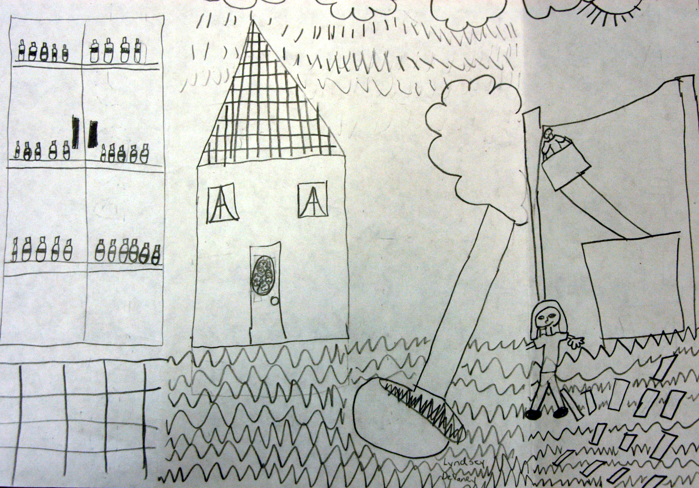
Lesson Plan: Katrina Triptych
Grade Level: Third Grade
Denise Tullier-Holly, Art Educator
Southeastern Louisiana University Laboratory School
Hammond, Louisiana
Objective: Using the triptych format, the students will design and construct an artwork their Hurricane Katrina experience.
Materials/Resources
8.5” x 11” paper
pencil
National Visual Art Standards
Content Standard #1: Understanding and applying media, techniques, and processes
Content Standard #2: Using knowledge of structures and functions
Content Standard #3: Choosing and evaluating a range of subject matter, symbols, and ideas
Content Standard #4: Understanding the visual arts in relation to history and cultures
Content Standard #5: Reflecting upon and assessing the characteristics and merits of their work and the work of others
Content Standard # 6: Making connections between visual arts and other disciplines

Katrina, before, during and after, Lyndsey DeVaney

Procedure
Day 1 – Introduction and triptych
Introduce the students to the triptych format, its history, and how it works. Explain that the prefix “tri” meaning three. The segments of the triptych will represent before, during and after Hurricane Katrina.
Begin the process by having the students recall their own family’s experiences of Hurricane Katrina.
To create a triptych, gently fold an 8.5” x 11” piece of paper in half, not creasing the fold. Open the paper, take each outside edge (right and left) and bring it to that centerline. Crease each of these folds; this creates two smaller side panels (before and after) and one large center panel (during Katrina). Have the students write their name at the bottom of the center panel toward the right and again on the back center panel. They may then begin to express their family stories in pencil.
Day 2 - Triptych and language arts inclusion
Students continue to draw their stories inside the triptych, before, during and after. Have them add symbols of hurricanes to the “front” doors of the triptych and include a title, Hurricane Katrina.
When students have completed their artwork, invite them to write their story on the large back. At completion, have a sharing time between students.
Notes: This process may be longer depending on the student completion and whether or not you introduce color to the process. These triptychs were a great source of affirmation to the students. It validated their experiences and allowed them to be empathic towards others.

